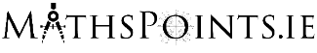
Brexit Indicators – Visualisation Tool

This activity is based around the Brexit Indicators: Ireland and the UK in Numbers visualisation tool which can be found here:
https://www.cso.ie/en/interactivezone/visualisationtools/brexitindicators/

Task 1 – Calculating the percentage of Ireland’s Trade in Services (Imports) that comes from the United Kingdom
We are first asked to select our area of interest from the following 6 categories. Select Trade in Services.
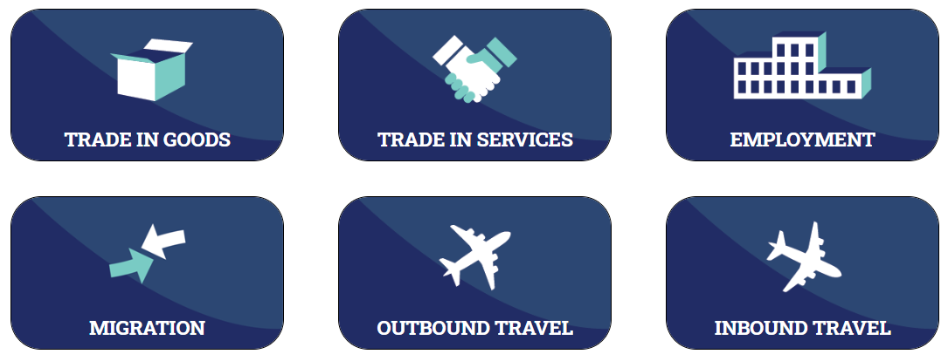
Use the data in the generated pie chart to calculate the percentage of Ireland’s Trade in Services (Imports) in 2018 that involved trade with the United Kingdom.
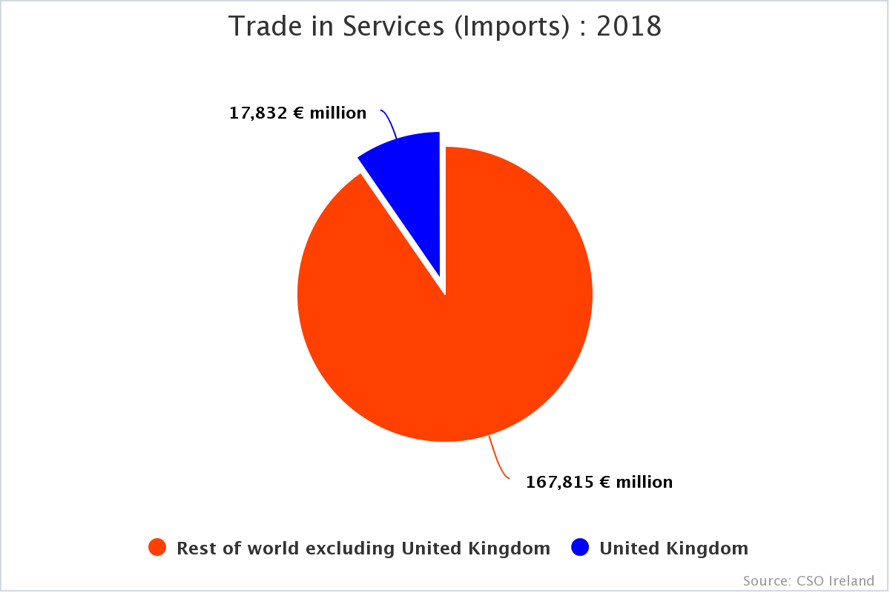

Task 2 – Interpreting the Trade in Services (Imports) Combined Bar Chart/ Trend Graph.
In the chart below the yellow bars represent Ireland’s Total Trade in Services (Imports) for that year, whilst the blue bar represents Ireland’s Trade in Services (Imports) with the United Kingdom for that year.
By hovering over each of the bars, taking note of the figures presented and performing relevant calculations explain the relationship between the light blue trend graph and the yellow and blue bars.
Comment on the any trends you observe in Ireland’s Trade in Services (Imports) from 2008 to 2018.

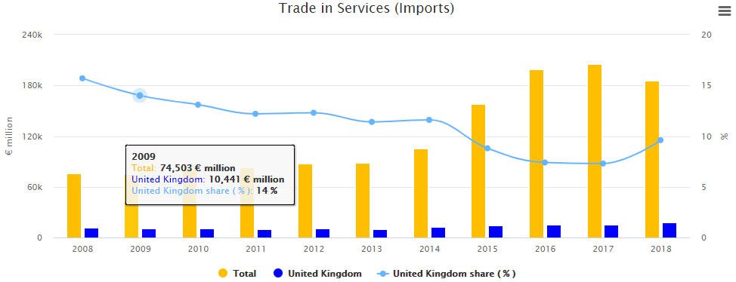

Task 3 – Repeat Tasks 1 and 2 for Ireland’s Trade in Services (Exports) using the charts on the bottom of the page.

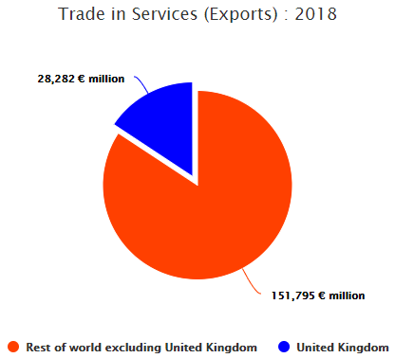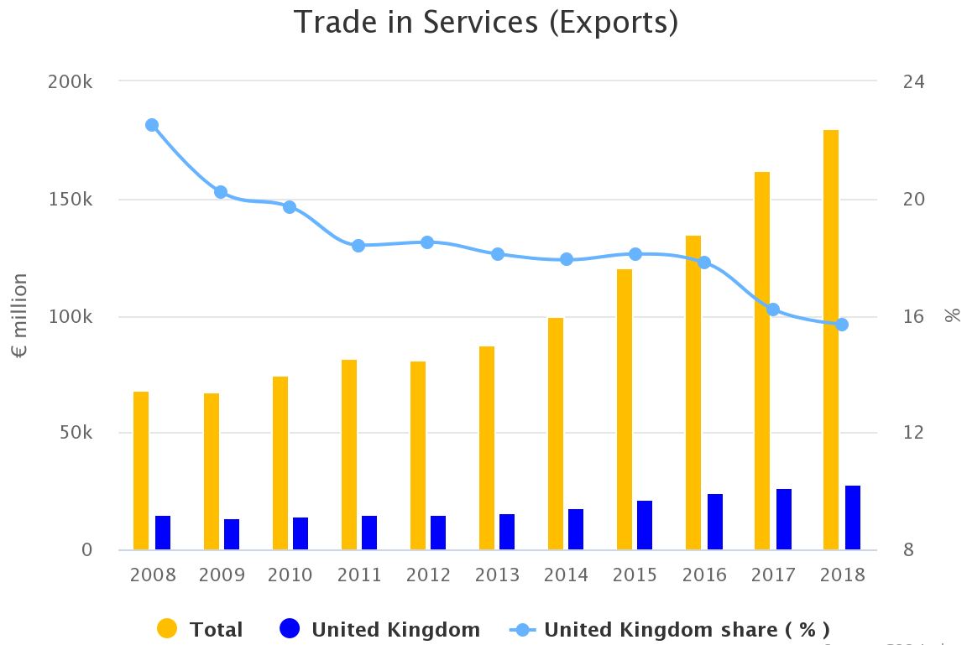

Task 4 – Calculating a Rolling Annual %
Select Outbound Travel.
In the chart below the yellow bars represent total number of trips by Irish residents to all countries (including Great Britain) for that quarter of a year, whilst the blue bar represents trips by Irish residents to Great Britain.
By hovering over any 4 consecutive pairs of yellow and blue bars, take note of the figures presented and perform relevant calculations to explain the relationship between the light blue trend graph (the Great Britain share as a rolling annual % of the total) and the yellow and blue bars.
What is your understanding of a ‘rolling annual %’? Why use a ‘rolling annual %’?
Comment on the any trends you observe in trips by Irish residents across the period presented by the chart. 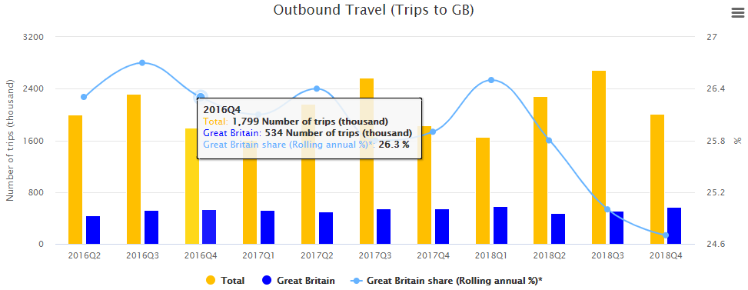

Task 5 – Calculating the average spend by Irish residents on trips to Great Britain and other countries.
Using both pie charts on the Outbound Travel page calculate the average spend per trip (for the period given):
- to Great Britain
- to the rest of the world excluding Great Britain
- to all countries

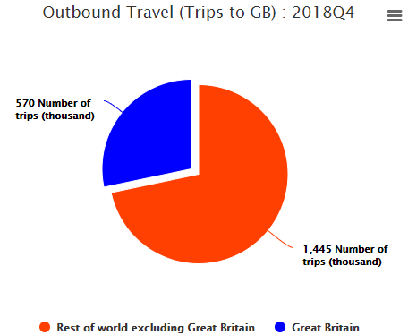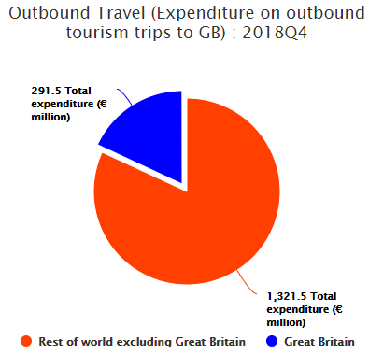

Make a comparison between the average expenditure on outbound trips to Great Britain versus the average expenditure on outbound trips to the rest of the world excluding Great Britain.

Sample Solutions

Task 1
The percentage of Ireland’s Trade in Services (Imports) in 2018 that involved trade with the United Kingdom.

$$=\frac{United Kingdom}{Total}×\frac{100}{1}$$
$$=\frac{17,832}{17,832+167,815}×\frac{100}{1}$$
$$=\frac{17,832}{185647}×\frac{100}{1}$$
$$=9.6\%$$

Task 2
The percentage of Ireland’s Trade in Services (Imports) in 2018 that involved trade with the United Kingdom.

$$=\frac{United Kingdom}{Total}×\frac{100}{1}$$
$$=\frac{10,441}{74,503}×\frac{100}{1}$$
$$=14\%$$

The light blue trend graph points are calculated by finding the percentage of the total Trade in Services (Imports) that are made up of trade with the United Kingdom.
We can see that this percentage has fallen since 2008 with a small rebound in 2018 illustrating Ireland’s decreasing reliance on Trade in Services (Imports) with the United Kingdom.

Task 3
The percentage of Ireland’s Trade in Services (Exports) in 2018 that involved trade with the United Kingdom.

$$=\frac{United Kingdom}{Total}×\frac{100}{1}$$
$$=\frac{28,282}{28,282+151,795}×\frac{100}{1}$$
$$=\frac{28,282}{180,077}×\frac{100}{1}$$
$$=15.7\%$$

The light blue trend graph points are calculated by finding the percentage of the total Trade in Services (Exports) that are made up of trade with the United Kingdom.
We can see that Trade in Services (Exports) with the United Kingdom as a percentage of overall Trade in Services (Exports) has also decreased over this time period highlighting Ireland’s increased Trade in Services with countries other than the United Kingdom.

Task 4
A rolling annual percentage can provide a more realistic look at a situation taking the last year into account as opposed to a snapshot from one particular quarter.
It calculates the percentage using four consecutive readings rather than one. Here we have taken 4 readings from 2016 Q4 to 2017 Q3.

Quarter | All | GB
2016 Q4 | 1799 | 534
2017 Q1 | 1607 | 519
2017 Q2 | 2162 | 502
2017 Q3 | 2572 | 543
Total | 8140 | 2098

Percentage of Trips in 2017 Q3 to Great Britain
$$=\frac{543}{2572}×\frac{100}{1}$$
$$=21.1\%$$

Rolling Annual Percentage of Trips to 2017 Q3 to Great Britain
$$=\frac{2098}{8140}×\frac{100}{1}$$
$$=25.8\%$$

Note this matches the figure given on the chart for the 2017 Q3 rolling average and represents the point on the light blue trend graph.

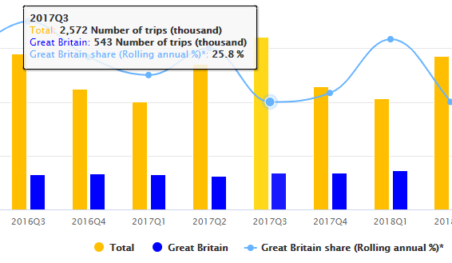

Task 5
Average spend by Irish residents on trips to Great Britain.
$$=\frac{291,500,000}{570,000}$$
$=€511.40$

Average spend by Irish residents on trips to Rest of the World excluding Great Britain.
$$=\frac{1,321,500,000}{1,445,000}$$
$=€914.53$

Average spend by Irish residents on trips to all countries.
$$=\frac{291,500,000+1,321,500,000}{570,000+1,445,000}$$
$$=\frac{1,613,000,000}{2015000}$$
$=€800.50$

