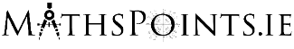
House Prices by Eircode – Visualisation Tool

This activity is based around the House Prices by Eircode visualisation tool which can be found here:
https://www.cso.ie/en/interactivezone/visualisationtools/housepricesbyeircode/

Task 1 – Searching for Your Area
The first screen we are met with asks us to ‘Enter Your Eircode Routing Key or Area Name’.
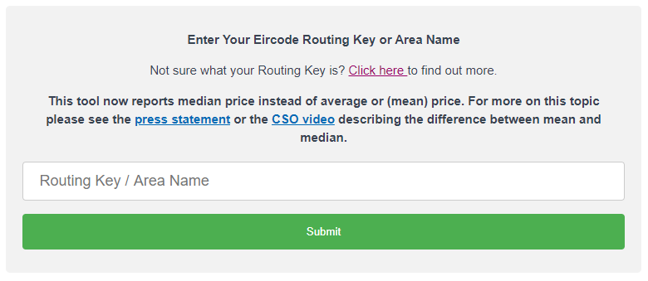
The routing key is the first 3 digits of your Eircode. If you are unsure of your Eircode you can find it at:
https://www.eircode.ie/
Once you have your Eircode enter the first 3 digits (the routing key) into the text box and click submit to select your area.
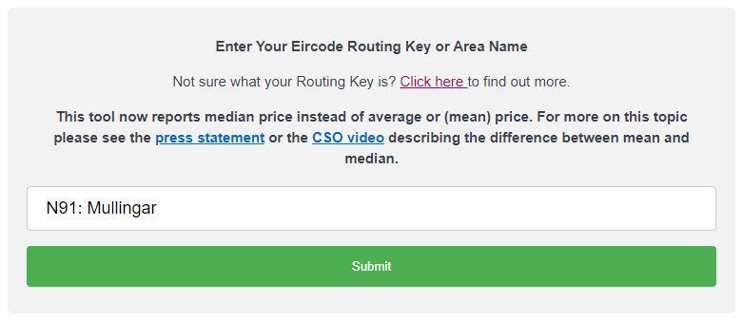
This will bring up the median price of residential properties sold in your area.
Why do you think the median price is given instead of the mean?

Task 2 – Compare the Median price of residential properties in your area to the National Median price of residential properties.

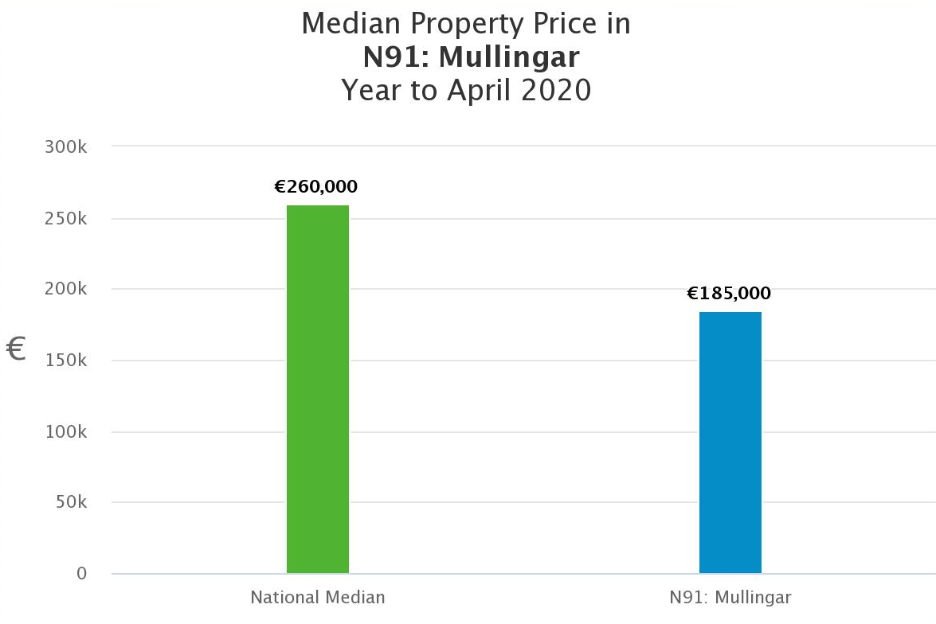
Calculate what the median price is in your area as a percentage of the national median price using:

$$\frac{Your Area Median Price}{National Median Price}×100$$

Task 3 – Comment on the Distribution of Buyer Types in Your Area Using the Pie Chart that was Generated.

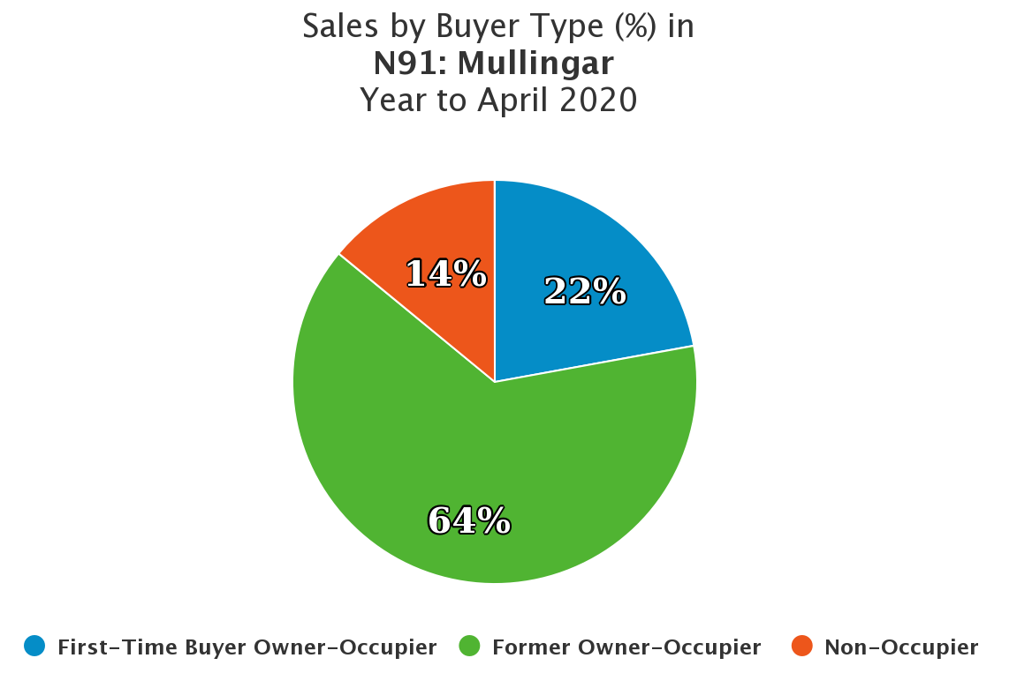
Do you think the breakdown of buyer types in your area is reflective of the breakdown nationally?
Justify your decision by selecting a sample of other areas in Ireland from the ‘Enter Your Eircode Routing Key or Area Name’ and viewing their charts.

Task 4 – Comment on the Trend in Volume of Sales by Dwelling Status from January 2010.

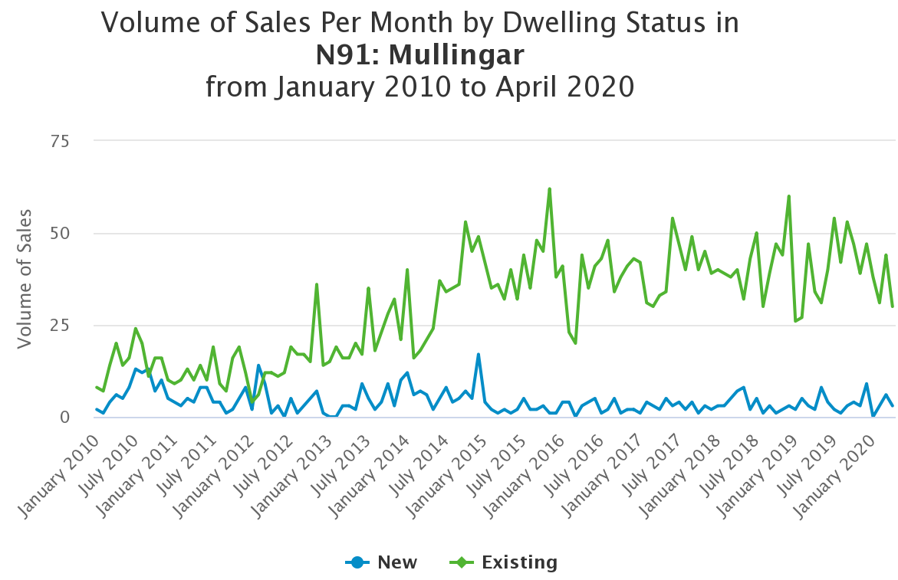
Do you think the trends of sales for both new and existing dwellings in your area is reflective of the trends nationally?
Justify your decision by selecting a sample of other areas in Ireland from the ‘Enter Your Eircode Routing Key or Area Name’ and viewing their charts.

Sample Solutions

Task 1
The median is a good measure of the middle of a set of data that may have outliers.
Extreme values, such as unusually expensive houses, do not affect the median as strongly as they do the mean.

Task 2
The median price in Mullingar as a percentage of the national median price using:

$$\frac{Mullingar Median Price}{National Median Price}×100$$
$$=\frac{185,000}{260,000}×100$$
$$=71.15\%$$

The median price of a property in Mullingar is 71.15% of the median price of a property nationally.

