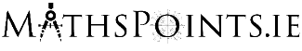
How Popular is Your Birthday? – Visualisation Tool

This activity is based around the How Popular is Your Birthday? visualisation tool which can be found here:
https://www.cso.ie/en/interactivezone/visualisationtools/howpopularisyourbirthday

Task 1 – Find Out the Popularity of Your Birthday
The first screen we are met with asks us to ‘select your birthday’.
Enter the month and day you were born to be presented with an infographic of how popular your birthday is.
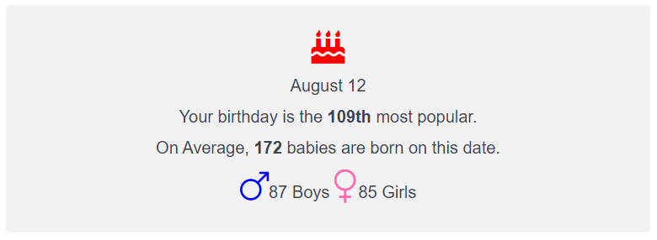

Task 2 – Calculate the Relative Frequency of Births by Month.
Scroll down the page to the chart showing the Average Number of Births Per Month. Use this chart to calculate the relative frequency of births for EACH month using:

$$Relative Frequency=\frac{Number of Births in Particular Month}{Total Number of Births}$$

For example the Relative Frequency of January Births is:

$$Relative Frequency=\frac{Number of Births in January}{Total Number of Births}$$

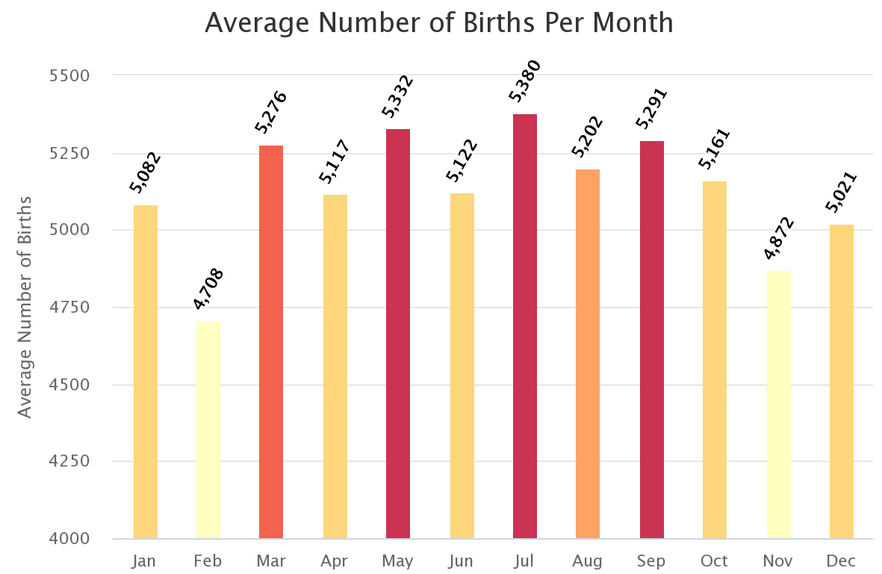

Having calculated the relative frequencies would you say that there is an equal chance of being born in any of the 12 months? Explain your answer making reference to the theoretical probability of being born in a particular month.
Is there anything misleading in the chart?

Sample Solution – Task 2

First calculate the total births by summing the totals for each month.
$$=5082+4708+5276+5117+5332+5122+5380+5202+5291+5161+4872+5021$$
$$=61564$$

Calculate the Relative Frequencies
$$Relative Frequency=\frac{Number of Births in January}{Total Number of Births}$$
$$Relative Frequency \left(JAN\right)=\frac{5082}{61564}=0.0825$$
$$Relative Frequency \left(FEB\right)=\frac{4708}{61564}=0.0765$$
$$Relative Frequency \left(MAR\right)=\frac{5276}{61564}=0.0857$$
$$Relative Frequency \left(APR\right)=\frac{5117}{61564}=0.0831$$
$$Relative Frequency \left(MAY\right)=\frac{5332}{61564}=0.0866$$
$$Relative Frequency \left(JUN\right)=\frac{5122}{61564}=0.0832$$
$$Relative Frequency \left(JUL\right)=\frac{5380}{61564}=0.0874$$
$$Relative Frequency \left(AUG\right)=\frac{5202}{61564}=0.0845$$
$$Relative Frequency \left(SEP\right)=\frac{5291}{61564}=0.0859$$
$$Relative Frequency \left(OCT\right)=\frac{5161}{61564}=0.0838$$
$$Relative Frequency \left(NOV\right)=\frac{4872}{61564}=0.0791$$
$$Relative Frequency \left(DEC\right)=\frac{5021}{61564}=0.0816$$

Calculate the Theoretical Probability of Being Born in a Particular Month
$$Theoretical Probability =\frac{1}{12}=0.0833$$

As the relative frequencies are close to the theoretical probability it would be justifiable to say there is an equal chance of being born in any of the months ($≈$8.33%). Whilst February and November do appear to have less births than the rest, the chart exaggerates the difference by starting at 4000 births and not 0.
The large dataset, however, does make it reasonable to argue that there is a higher chance of being born in July than February.

