Ireland’s Top Motors – Visualisation Tool

This activity is based around the Ireland’s Top Motors visualisation tool which can be found here:
https://www.cso.ie/en/interactivezone/visualisationtools/irelandstopmotors/

Task 1 – Identifying the Most Popular Car by Month
The first data we are presented with is the most popular new car in Ireland for the most recent month of recorded sales.
We can see that in May 2020 the most popular new car was the Tesla Model 3. Click ‘Show More’ to bring up the number of cars sold of that model (56), along with the rest of the top 10 for that month.
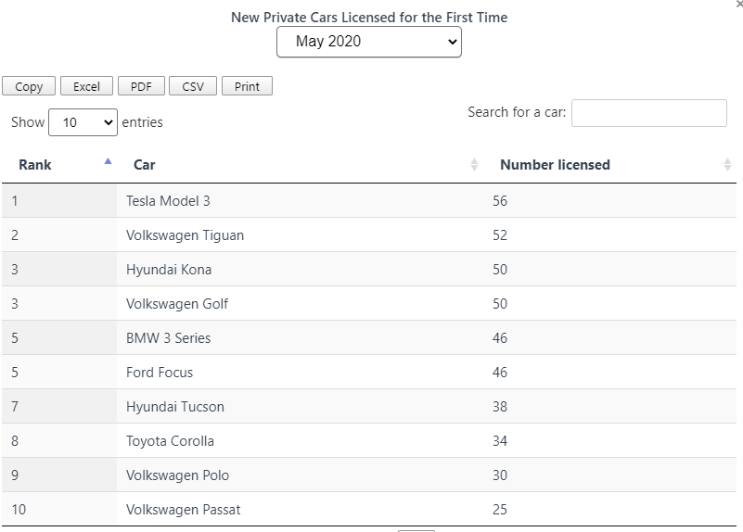
Task 2 – Calculating the Total Car Sales for a Particular Month
We will use an excel sheet to calculate the total number of car sales in a particular month. Click on the ‘Excel’ button to download data on all cars sold for that month.
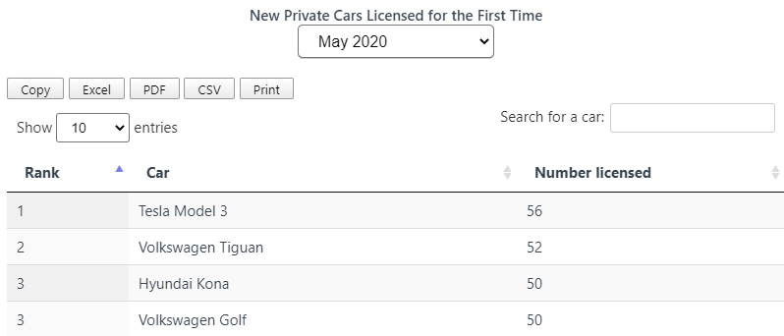
We want to sum all of the car sales in column C of the excel sheet to get the total number of car sales for that month. In the box directly underneath the last entry in column C enter the following text:
=sum(C2:C154)
Where C2 is the cell with the number of sales for the most popular car and C154 is the cell with the number of sales for the least popular car.

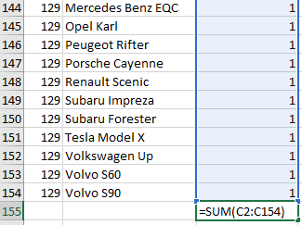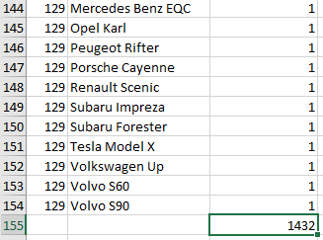

Press enter and this cell will now contain the TOTAL car sales for that month. For example in May 2020 there were 1,432 car sales in Ireland.

Task 3 – Calculating the number of sales of the most popular car in a particular month as a % of the total number of sales in that month.

For this we simply use the following formula:

$$\frac{Number of Sales of the Most Popular Car }{Total Number of Sales}×\frac{100}{1}$$

For example, to calculate the number of Tesla Model 3s sold in May 2020 as a percentage of the total number of cars sold in May 2020:

$$\frac{Sales of Tesla Model 3s}{Total Sales}×\frac{100}{1}$$
$$\frac{56}{1,432}×\frac{100}{1}=3.91\%$$
Perform your own calculations using a month of your choice.

Task 4 – Tracking the Popularity of Your Car From 2014 to 2019
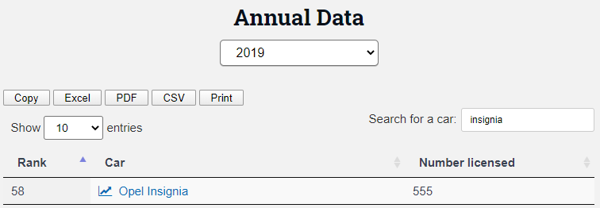
Enter the name of your own family car into the ‘Search for a car’ box of the Annual Data section. This will give the number of that model of car licensed in that year as well as its overall rank.
Select on the model of the car to bring up a combined bar chart/ trend graph of the rank. Comment on the sales of your car from 2014 to present.

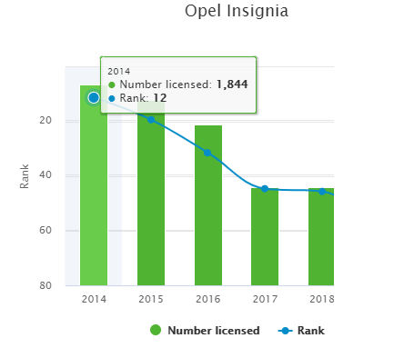
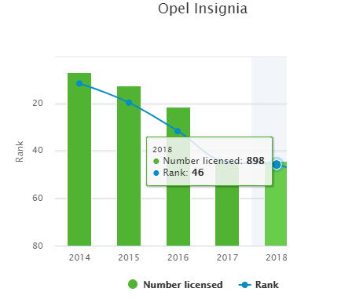
Hovering over a particular bar brings up the numbers of cars sold in that year along with the rank.
We can see that the Opel Insignia has declined in sales from 1,844 licensed in 2014 with a rank of 12 to 898 licensed in 2018 with a rank of 46.
Return to the Annual Data box and look up the number sold and the rank in 2019 to see if the trend for your car has continued. For example there were 555 Opel Insignias sold in 2019 showing a continued decline in their sales.

Task 5 – Trends of Fuel Types
Scrolling to the bottom of the page we can see charts for Sales of New Private Cars by Traditional Fuel (Petrol and Diesel) and Alternative Fuels (Hybrid, Electric and Other).

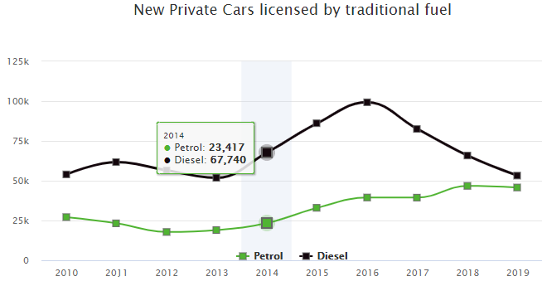
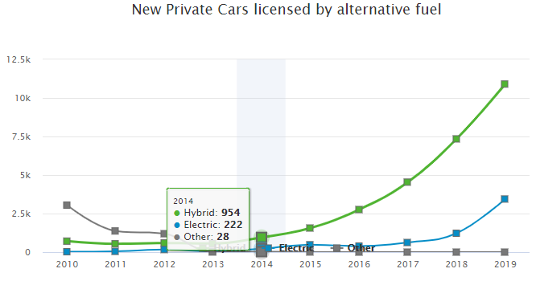
Comment on the trends illustrated by each chart and then combine the data to create one chart so that we may directly compare the Traditional Fuels with the Alternative Fuels.

Calculate for each of the years 2010 to present what percentage of cars licenced had alternative fuel.

For example in 2014:

$$\frac{Alternative Fuel Types}{All Fuel Types}×\frac{100}{1}$$
$$=\frac{954+222+28}{954+222+28+23417+67740}×\frac{100}{1}$$
$$=\frac{1204}{92361}×\frac{100}{1}$$
$$=1.3\%$$

Use the results to comment on the trend of sales of alternative fuelled cars sold as a percentage of all cars sold from 2010 to present.

Task 6 – Percentage of Imported Cars
The final chart on the page shows the sales of All Private Cars Licensed both New and Imported.
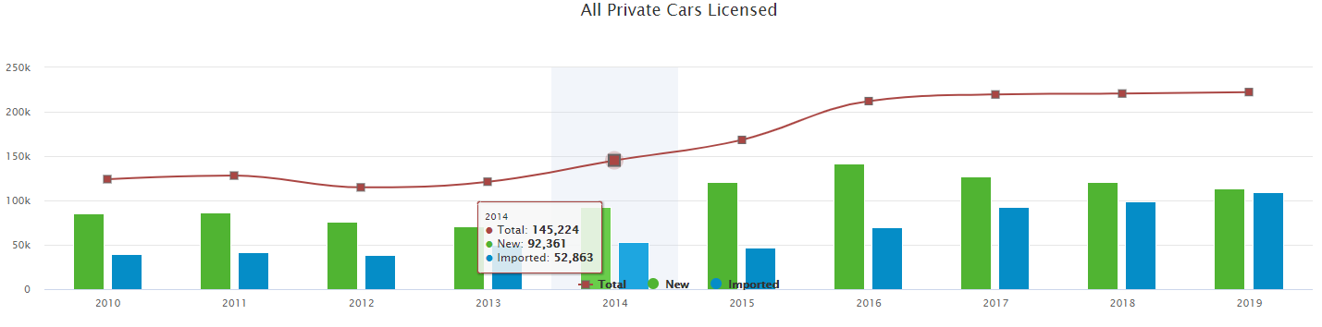
Calculate for each of the years 2010 to present what percentage of cars licenced had been imported.
Use the results to comment on the trend of sales of imported cars licensed as a percentage of all private cars licensed from 2010 to present.

